Bible Study Application Help

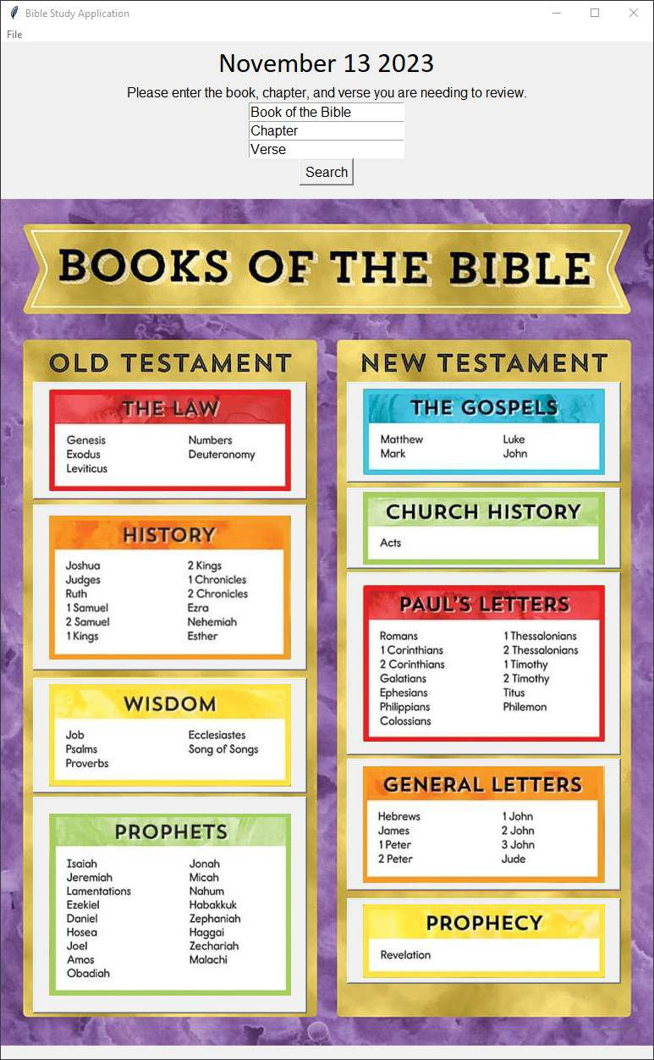

Welcome to the Bible Study Applica on. This applica on will help you keep track of your daily readings, give you the op on to search the American Standard Version of the Bible, along with several other items.

If you click on the File menu in the upper le#-hand corner will show the following menu.

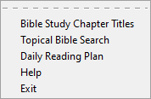

When you click on the “Bible Study Chapter Titles” a PDF document will display showing ever single book of the Bible with the diﬀerent tles of each of the chapters.

“Topical Bible Search” will link out to a website created by OpenBible allowing the user to run a search on the diﬀerent topics in the bible. For example, if searching for breakfast, it will pull up a list of the diﬀerent verses on breakfast.

“Daily Reading Plan” will pull up an Excel document allowing you to mark your daily reading on the Bible complete and add any notes needed on the reading.

“Help” will show the user this help document. “Exit” of course will close out of the applica on.

The user has the op on of searching for a speciﬁc verse in the Bible by using the search at the top of the window. Please make sure that when entering in the book name, you have a capital le1er. If not, it will not search correctly. Once you click the search bu1on it will pull up the screen below. Once the user has reviewed the verse, just click the close bu1on out of the addi on window.

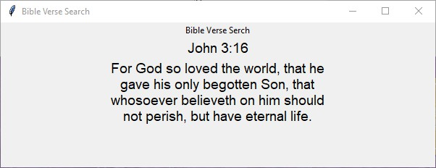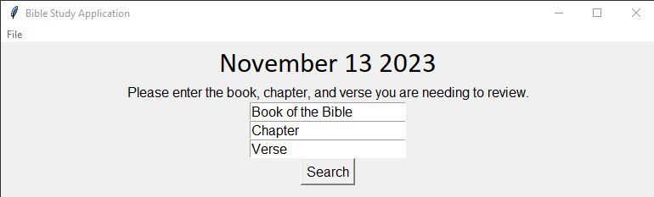

Finally, on the Books of the Bible background, each breakout of the book has a bu1on. When the user clicks on these bu1ons a PDF document will appear giving a descrip on of and a descrip on of each of the books.

